1. Dataset plot
In this problem, we use the fetch_20newsgroups dataset from sklearn package to plot the number of training documents per class.
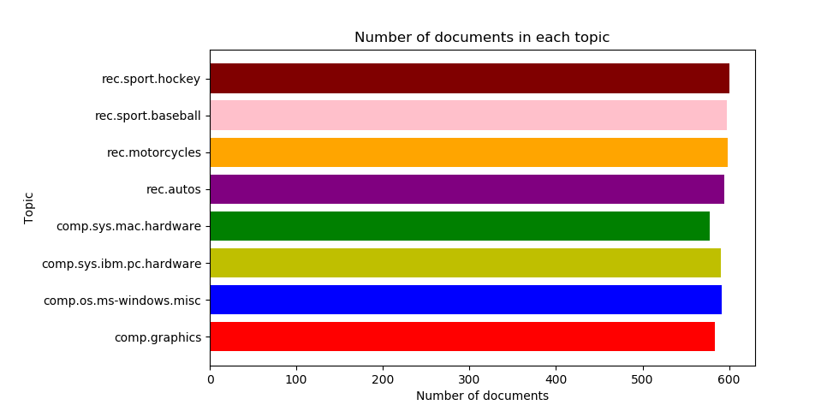
From the figure above, we could see that the data set is already balanced and in every class the number of documents is almost equivalent.

2. Create TF*IDF vector representation

A popular numerical statistic to capture the importance of a word is TFxIDF metric. This measure takes into account the words in the document. The discriminating words will most likely be those that are specialized terms describing different types of accessories and hence will occur in fewer documents.
In this problem, we need to convert the documents of 8 classes into numerical feature vectors. Firstly, we use ‘snowball’ to remove morphological affixes from words. After that, we remove all punctuation, all symbols and non-ascii characters. We used TfidfTransformer to calculate TFIDF, where tf(t, d) represents the frequency of term t in document d, and inverse document frequency is defined as: idf(t) = log [ n / df(t)] + 1 and df(t) is the document frequency; the document frequency is the number of documents that contain the term t.

Token shape: (1175, 11908) [min_df = 2, enable_stopword = True, enable_stem = True]

TFxIDF shape: (1175, 11908) [min_df = 2, enable_stopword = True, enable_stem = True]

[min_df = 2] Number of terms: 11908

Token shape: (1175, 4304) [min_df = 5, enable_stopword = True, enable_stem = True]

TFxIDF shape: (1175, 4304) [min_df = 5, enable_stopword = True, enable_stem = True]

[min_df = 5] Number of terms: 4304

3. Calculate the TF*ICF
In order to quantify how significant a word is to a class, we calculate TFxICF. It is the same as TFxIDF, except that a class sits in place of a document; that is for a term t and a class c. And we need to find the 10 most significant terms in each of the 4 classes with respect to TFICF measure.

comp.sys.ibm.pc.hardware [u'scsi', u'drive', u'edu', u'ide', u'line', u'use', u'com', u'subject', u'organization', u'controller']

comp.sys.mac.hardware [u'edu', u'line', u'mac', u'subject', u'organization', u'apple', u'use', u'quadra', u'scsi', u'problem']

misc.forsale [u'edu', u'line', u'sale', u'subject', u'organization', u'new', u'post', u'com', u'university', u'offer']

soc.religion.christian [u'god', u'edu', u'christian', u'jesus', u'say', u'church', u'subject', u'people', u'line', u'know']

4. In this problem, we need to transform the data’s dimensional into a lower dimensional space. We use Latent Semantic Indexing (LSI) and NMF to lower the space into 50. As to LSI, we used the SVD decomposition to obtain left and right singular vectors and then get a lower space.

Token shape: (4732, 24849) [min_df = 2, enable_stopword = True, enable_stem = True]

TFxIDF shape: (4732, 24849) [min_df = 2, enable_stopword = True, enable_stem = True]

Shape of feature vec after LSI: (4732, 50)

Shape of feature vec after NMF: (4732, 50)

5. In next parts, we need to classify the documents into two categories ‘‘Computer Technology’ vs ‘Recreational Activity’. We need to combine documents of sub-classes of each class to form the set of documents for each class. And we need to assess the model by precision, recall and ROC curve.
In this part, based on LSI and NMF,we used SVM to make classification.

1) Hard- SVM with LSI

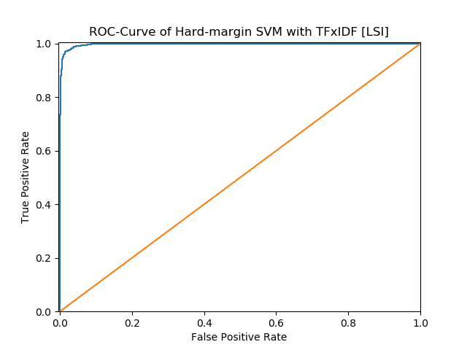

 | Precision | Recall | Accuracy
Computer technology | 0.9938 | 0.9295 | 0.9622
Recreational activity | 0.9349 | 0.9943 | 0.9622
Average | 0.9619 | 0.9644 | 0.9622

 | TP | FP | FN | TN
Computer technology | 1450 | 9 | 110 | 1581
Recreational activity | 1581 | 110 | 9 | 1450

We set computer technology as positive and recreational activity as negative to construct the confusion matrix as follow:

 | Ground Truth | Ground False
Predicted positive | 1450 | 9
Predicted negative | 110 | 1581

2) Hard- SVM with NMF
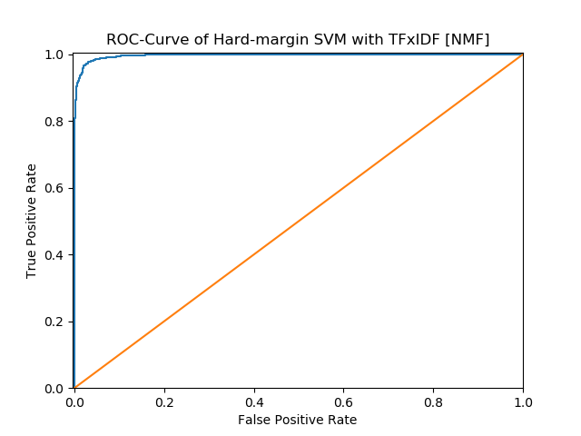

 | Precision | Recall | Accuracy
Computer technology | 0.9916 | 0.9090 | 0.9511
Recreational activity | 0.9174 | 0.9925 | 0.9511
Average | 0.9507 | 0.9545 | 0.9511

 | TP | FP | FN | TN
Computer technology | 1418 | 12 | 142 | 1578
Recreational activity | 1578 | 142 | 12 | 1418

We set computer technology as positive and recreational activity as negative to construct the confusion matrix as follow:
 | Ground Truth | Ground False
Predicted positive | 1418 | 12
Predicted negative | 142 | 1578

3) Soft- SVM with LSI
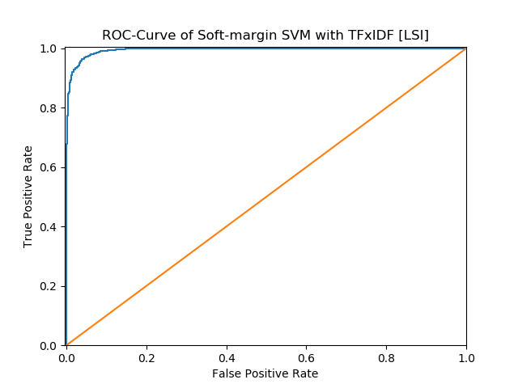

 | Precision | Recall | Accuracy
Computer technology | 0.9922 | 0.8917 | 0.9429
Recreational activity | 0.9033 | 0.9931 | 0.9429
Average | 0.9424 | 0.9477 | 0.9429

 | TP | FP | FN | TN
Computer technology | 1391 | 11 | 169 | 1579
Recreational activity | 1579 | 169 | 11 | 1391
We set computer technology as positive and recreational activity as negative to construct the confusion matrix as follow:
 | Ground Truth | Ground False
Predicted positive | 1391 | 11
Predicted negative | 169 | 1579
4) Soft- SVM with NMF
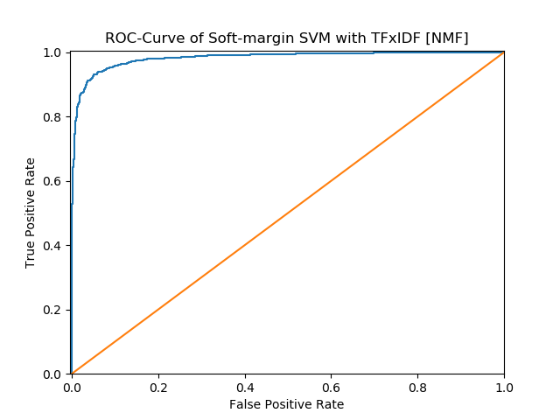

 | Precision | Recall | Accuracy
Computer technology | 1.0000 | 0.0410 | 0.5251
Recreational activity | 0.5152 | 1.0000 | 0.5251
Average | 0.5205 | 0.7576 | 0.5251

 | TP | FP | FN | TN
Computer technology | 64 | 0 | 1496 | 1590
Recreational activity | 1590 | 1496 | 0 | 64
We set computer technology as positive and recreational activity as negative to construct the confusion matrix as follow:
 | Ground Truth | Ground False
Predicted positive | 64 | 0
Predicted negative | 1496 | 1590

6.

